A

Major Project On

**MORSECODE TRANSLATOR USING EYE BLINKS**

(Submitted in partial fulfillment of the requirements for the award of Degree) BACHELOR OF TECHNOLOGY

in

COMPUTER SCIENCE AND ENGINEERING

By

C. Sainath(187R1A05C9)

G. Srikar(187R1A05E3)

I. Pranay Goud(187R1A05E8)

Under the Guidance of

**MRS. G. KAVITHA REDDY**

Assistant Professor



## DEPARTMENT OF COMPUTER SCIENCE AND ENGINEERING

**CMR TECHNICAL CAMPUS**

**UGC AUTONOMOUS**

(Accredited by NAAC, NIRF, NBA, Permanently Affiliated to JNTUH, Approved by AICTE, New Delhi) Recognized Under Section 2(f) & 12(B) of the UGC Act.1956,

Kandlakoya (V), Medchal Road, Hyderabad-501401.

**2018-22**

## DEPARTMENT OF COMPUTER SCIENCE AND ENGINEERING



**CERTIFICATE**

This is to certify that the project entitled “MORSECODE TRANSLATOR USING EYEBLINKS” being submitted by **C.SAINATH(187R1A05C9), G.SRIKAR(187R1A05E3) & I.PRANAY GOUD(187R1A05E8)** in partial fulfillment of the requirements for the award of the degree of B.Tech in Computer Science and Engineering to the Jawaharlal Nehru Technological University Hyderabad, is a record of bonafide work carried out by him/her under our guidance and supervision during the year 2021-22.

The results embodied in this thesis have not been submitted to any other University or Institute for the award of any degree or diploma.

**Mrs. G. Kavitha Reddy Dr. A. Raji Reddy**

**Assistant Professor DIRECTOR**

**INTERNAL GUIDE**

**Dr. K. Srujan Raju EXTERNAL EXAMINER**

**HOD**

**Submitted for viva voice Examination held on**

**ACKNOWLEGDEMENT**

Apart from the efforts of us, the success of any project depends largely on the encouragement and guidelines of many others. We take this opportunity to express our gratitude to the people who have been instrumental in the successful completion of this project.

We take this opportunity to express my profound gratitude and deep regard to my guide **Mrs. G. Kavitha Reddy,** AssistantProfessor for her exemplary guidance, monitoring and constant encouragement throughout the project work. The blessing, help and guidance given by him shall carry us a long way in the journey of life on which we are about to embark.

We also take this opportunity to express a deep sense of gratitude to Project Review Committee (PRC) **Mr. A. Uday Kiran, Mr. J. Narasimha Rao, Dr. T. S. Mastan Rao, Mrs. G. Latha, Mr. A. Kiran Kumar,** for their cordial support, valuable information and guidance, which helped us in completing this task through various stages.

We are also thankful to **Dr. K. Srujan Raju,** Head, Department of Computer Science and Engineering for providing encouragement and support for completing this project successfully.

We are obliged to **Dr. A. Raji Reddy,** Director for being cooperative throughout the course of this project. We also express our sincere gratitude to Sri. **Ch. Gopal Reddy,** Chairman for providing excellent infrastructure and a nice atmosphere throughout the course of this project.

The guidance and support received from all the members of **CMR Technical Campus** who contributed to the completion of the project. We are grateful for their constant support and help.

Finally, we would like to take this opportunity to thank our family for their constant encouragement, without which this assignment would not be completed. We sincerely acknowledge and thank all those who gave support directly and indirectly in the completion of this project.

**C.SAINATH (187R1A05C9) G.SRIKAR (187R1A05E3) I.PRANAY GOUD (187R1A05E8)**

**ABSTRACT**

Morse code is a method used in telecommunication/communication to encode text characters as standardized sequences of two different signal durations, called dots and dashes, or dits and dahs. Morse Code encodes the 26 Latin letters a through z, one non-Latin letter, the Arabic numerals, and a small set of punctuation and procedural signals (prosigns). There is no distinction between upper and lower case letters. Each Morse code symbol is formed by a sequence of dits and dahs. The dit duration is the basic unit of time measurement in Morse code transmission. The duration of a dah is three times the duration of a dit. Each dit or dah within an encoded character is followed by a period of signal absence, called a space, equal to the dit duration. The letters of a word are separated by a space of duration equal to three dits, and words are separated by a space equal to seven dits.

**LIST OF FIGURES/TABLES**

|  |  |  |
| --- | --- | --- |
| **FIGURE NO** | **FIGURE NAME** | **PAGE NO** |
| Figure 3.1 | Project Architecture | 8 |
| Figure 3.2 | Use case diagram | 11 |
| Figure 3.3 | Class diagram | 12 |
| Figure 3.4 | Sequence diagram | 13 |
| Figure 3.5 | Activity diagram | 14 |

**LIST OF SCREENSHOTS**

|  |  |  |
| --- | --- | --- |
| **SCREENSHOT NO.** | **SCREENSHOT NAME** | **PAGE NO**. |
| Screenshot 5.1 | Face mesh landmarks | 22 |
| Screenshot 5.2 | Left eye landmarks | 22 |
| Screenshot 5.3 | Right eye landmarks | 23 |
| Screenshot 5.4 | General morsecode | 23 |
| Screenshot 5.5 | morsecode for hello, hello converted to hindi | 24 |
| Screenshot 5.6 | morsecode for egg, egg converted to telugu | 24 |
| Screenshot 5.6 | morsecode for welcome, welcome converted to japanese | 24 |

|  |  |
| --- | --- |
| **ABSTRACT** | i |
| **LIST OF FIGURES** | ii |
| **LIST OF SCREENSHOTS** | iii |
| **1.** **INTRODUCTION** | **1** |
| 1.1 PROJECT SCOPE | 1 |
| 1.2 PROJECT PURPOSE | 1 |
| 1.3 PROJECT FEATURES | 1 |
| **2.** **SYSTEM ANALYSIS** | **2** |
| 2.1 PROBLEM DEFINITION | 2 |
| 2.2 EXISTING SYSTEM | 3 |
| 2.2.1 DISADVANTAGES OF THE EXISTING SYSTEM | 3 |
| 2.3 PROPOSED SYSTEM | 4 |
| 2.3.1 ADVANTAGES OF PROPOSED SYSTEM | 4 |
| 2.4 FEASIBILITY STUDY | 5 |
| 2.4.1 ECONOMIC FEASIBILITY | 5 |
| 2.4.2 TECHNICAL FEASIBILITY | 6 |
| 2.4.3 BEHAVIORAL FEASIBILITY | 6 |
| 2.5 HARDWARE & SOFTWARE REQUIREMENTS | 7 |
| 2.5.1 HARDWARE REQUIREMENTS | 7 |
| 2.5.2 SOFTWARE REQUIREMENTS | 7 |
| **3.** **ARCHITECTURE** | **8** |
| 3.1 PROJECT ARCHITECTURE | 8 |
| 3.2 ARCHITECTURE DESCRIPTION | 9 |
| 3.3 MODULES DESCRIPTION | 10 |
| 3.4 USE CASE DIAGRAM | 11 |
| 3.5 CLASS DIAGRAM | 12 |
| 3.6 SEQUENCE DIAGRAM | 13 |
| * 1. ACTIVITY DIAGRAM | 14 |
| 4. IMPLEMENTATION 15  4.1SAMPLECODE  **5. SCREENSHOTS** | 15  15  22 |

iv

|  |  |
| --- | --- |
| **6. TESTING** | 25 |
| 6.1 INTRODUCTION TO TESTING | 25 |
| 6.2 TYPES OF TESTING | 25 |
| 6.2.1 UNIT TESTING | 25 |
| 6.2.2 INTEGRATION TESTING | 25 |
| 6.2.3 FUNCTIONAL TESTING | 26 |
| 6.3 TESTCASES | 26 |
| 6.3.1 TEST CASES DESCRIPTION | 27 |
| **7. CONCLUSION & FUTURE SCOPE** | 28 |
| 7.1 PROJECT CONCLUSION | 28 |
| 7.2 FUTURE SCOPE | 28 |
| **8. BIBLIOGRAPHY** | 29 |
| 8.1 REFERENCES | 29 |
| 8.2 GITHUB LINK | 29 |

v

* 1. **INTRODUCTION**
     1. **INTRODUCTION**

**1.1 PROJECT SCOPE**

This project is titled as “MorseCode Translator” this software provides the facility to convert MorceCode into normal human readable language, this useds machine learning methodologies and EAR(Eye Aspect Ratio) to calculate dits and dahs using predefined facemesh model from mediapipe. So, this system is intended to provide an alternative form of communication for people with disabilities and to convey confidential messages.

#### 1.2 PROJECT PURPOSE

The main purpose/objective of this project is to convert morsecode into english along with other regional Indian languages like telugu, hindi etc. This will provide the feature where user eliminates third person translator while conversing using morsecode, this model finds dits and dahs by EAR value and time constrains given by the developer, appends each character and converts English language into regional languages along with speech. With this software, a person can express themselves faster and easier. It is important to solve the problem for such people who can communicate with every person in the world.

#### 1.3 PROJECT FEATURES

This project scheme was developed to increase the accuracy and to reduce the amount of work for people who doesn’t know morsecode. It also helps minimize the amount of time and money spent by removing third party translators. As everything is digitalized and based on data analysis, it takes less amount of time to get results. Based on the results, further action can be taken.

CMRTC 1

# 2. SYSTEM ANALYSIS

## SYSTEMANALYSIS

#### SYSTEM ANALYSIS

System Analysis is the important phase in the system development process. The System is studied to the minute details and analyzed. The system analyst plays an important role of an interrogator and dwells deep into the working of the present system. In analysis, a detailed study of these operations performed by the system and their relationships within and outside the system is done. A key question considered here is, “what must be done to solve the problem?” The system is viewed as a whole and the inputs to the system are identified. Once analysis is completed the analyst has a firm understanding of what is to be done.

#### 2.1 PROBLEM DEFINITION

With this software, a person can express themselves faster and easier. It is important to solve the problem for such people who can communicate with every person in the world. As we saw in the current systems they are not easy with people who have spinal cord injuries and all. Also, the efficiencies are not up to the mark for their current systems available. Nowadays every other laptop has a camera, if not available then USB extended cameras are also available. This component of the system is most costly whereas others are inexpensive. This system will be very efficient for the people who can easily blink their eyes and have some of the other physical disability. This system can be made more accurate with pre defined face mesh model. Due to the technological advancement, its scope is infinite we can completely make it voice activated and navigated.

CMRTC 2

**2.2 EXISTING SYSTEM**

The manual analysis of complex-natured, is fairly a time-consuming and tedious process, and could be prone to errors, For ages the morse code has been used by many government officials during emergencies and when the normal means of communication are not available, and it is also a type of sign language used by people to communicate. We found some of the existing models like morse code translation using sound that works on the principle of sound clicks. In this method, the person will communicate with his eyes and another person need to convert it into sound (click) and that must be decoded into human-understandable language. A few existing systems have devised different representations (or) data patterns of 0’s and 1’s to represent a character. In this model input is taken in form of eye blinks, short blink means a dit , long blink means dah.

**2.2.1 DISADVANTAGES OF EXISTING SYSTEM**

* Third party translators are needed.
* Time consuming.
* Error prone or accuracy.

#### 2.3 PROPOSED SYSTEM

In the proposed system we plan on using opencv, mediapipe to convert the morse code that is done by using different eye blinks into simple text , MediaPipe offers open source cross-platform, customizable ML solutions for live and streaming media.”, this definition is from their own website and explains what you can do with that library shortly and cleanly, they offer several other solutions that can run on different platforms and I’ll explain all of them in a different post in the future. The feature that we’ll use today is called “Face Mesh”, this solution provides us a face landmark map with the most important 468 landmarks that can be seen in a human’s face. Using that map we’ll calculate the ratio between some particular points in the face and with that information we’ll detect if the person on the camera blinked or not. To be able to detect if an eye is blinked or not we use “ear” ratio which stands for “eye aspect ratio” to be able to calculate an eye’s “ear” value we need to access 6 landmarks at one’s face. The text is then converted to other regional languages along with text and speech.

#### 2.3.1 ADVANTAGES OF THE PROPOSED SYSTEM

* Reduces costs.
* Accurate.
* Time saving.

#### 2.4 FEASIBILITY STUDY

The feasibility of the project is analyzed in this phase and business proposal is put forth with a very general plan for the project and some cost estimates. During system analysis the feasibility study of the proposed system is to be carried out. This is to ensure that the proposed system is not a burden to the company. Three key considerations involved in the feasibility analysis are

* Economic Feasibility
* Technical Feasibility
* Social Feasibility

#### 2.4.1 ECONOMIC FEASIBILITY

The developing system must be justified by cost and benefit. Criteria to ensure that effort is concentrated on project, which will give best, return at the earliest. One of the factors, which affect the development of a new system, is the cost it would require.

The following are some of the important financial questions asked during preliminary investigation:

* + The costs conduct a full system investigation.
  + The cost of the hardware and software.
  + The benefits in the form of reduced costs or fewer costly errors.

Since the system is developed as part of project work, there is no manual cost to spend for the proposed system. Also, all the resources are already available, it gives an indication of the system is economically possible for development.

#### 2.4.2 TECHNICAL FEASIBILITY

This study is carried out to check the technical feasibility, that is, the technical requirements of the system. Any system developed must not have a high demand on the available technical resources. The developed system must have a modest requirement, as only minimal or null changes are required for implementing this system.

#### 2.4.3 BEHAVIORAL FEASIBILITY

This includes the following questions:

* Is there sufficient support for the users?
* Will the proposed system cause harm?

The project would be beneficial because it satisfies the objectives when developed and installed. All behavioral aspects are considered carefully and conclude that the project is behaviorally feasible.

CMRTC 6

#### 2.5 HARDWARE & SOFTWARE REQUIREMENTS

**2.5.1 HARDWARE REQUIREMENTS:**

##### For developing the application, the following are the Hardware Requirements:

* Processor : intel i5 10th generation
* RAM : 4GB
* Hard Disk : 10GB
* Input Device : Standard keyword and Mouse, HD webcam
* Output Device : VGA and high resolution monitor, speaker

**2.5.2 SOFTWARE REQUIREMENTS:**

##### For developing the application, the following are the Software Requirements:

* Operating system : windows 10
* Anaconda with python3
* Spyder/Jupyter Notebook
* Open cv
* MediaPipe
* Gtts
* Play Sound
* Goggletrans

CMRTC 7

# ARCHITECTURE

## ARCHITECTURE

#### 3.1 PROJECT ARCHITECTURE

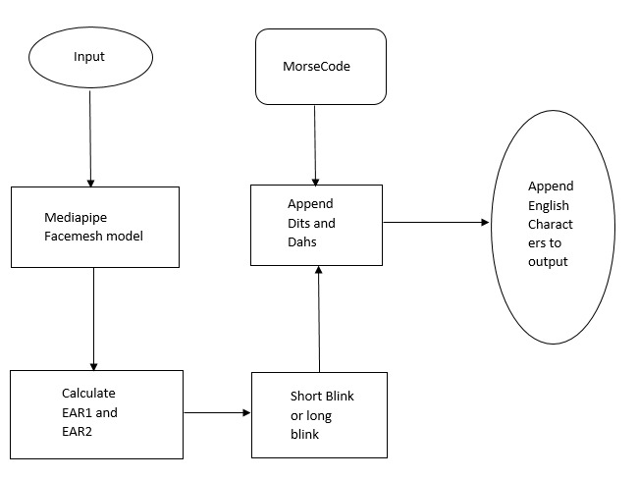

Figure 3.1: Project Architecture of Morse Code Translator

CMRTC 8

#### 3.2 ARCHITECTURE DESCRIPTION

**Input:**

Input can be taken using a camera or a video, for taking input we use opencv software .

**Mediapipe facemesh model:**

The input is processed here, that is face mesh model is applied on face for calculating EAR

**Calculate EAR1 and EAR2:**

EAR1 and EAR2 are calculated for both eyes based on the formula taken.

**Short blink or long blink:**

If EAR value is less than threshold then it’s a blink, calculate time interval to find whether it’s a dit or dah.

**Append dits and dahs:**

Append all dits and dahs to form a sequence.

**Morse code:**

Here the actual morcecode and sequence language are present in map data structure, map the sequence taken and find appropriate alphabet.

**Append English characters to output string:**

Now each character is appended to the output value to form a word, this word in turn converted to other languages and speech.

CMRTC 9

**3.3 MODULES DESCRIPTION**

**MODULE-1 (Input pre-processing)**

Take input from a webcam or a video using opencv, convert the BGR input to RGB input, pass it to Media pipe Facemesh Model.

**MODULE-2 (EAR calculation)**

Mediapipe detects face and maps landmarks, calculate ear1 and ear 2 based on the landmarks, initialize count.

**MODULE-3 (Dit or Dah)**

If count is 0 then add a value else if count==10 count=0, check ear 1 and ear2, if both of them are less than threshold value then its blink, based on fps find whether its a short blink or long blink, append the value to the string.

**MODULE-4 (Output)**

If blinking stopped then, if there is character matching then append it to output word, array, and then convert it to the string, convert the string from English to any other language using gtts, print the output.

#### 3.4 USECASE DIAGRAM

A use case is a set of scenarios that describing an interaction between a user and a system. A use case diagram displays the relationship among actors and use cases. The two main components of a use case diagram are use cases andactors.

Actors in use case diagram are:

* Speaker
* Listener

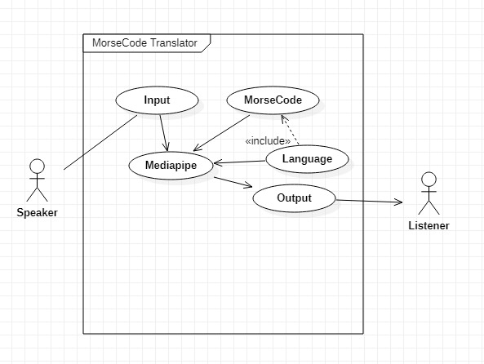

Figure 3.2: Use Case Diagram for user for MorseCode Translator

#### 3.5 CLASS DIAGRAM

Class Diagram is a collection of classes and objects.

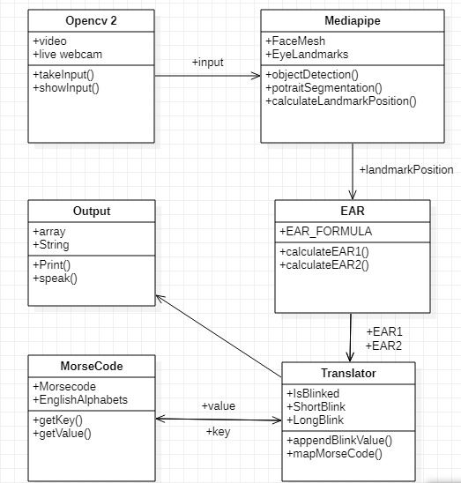

Figure 3.3: Class Diagram for MorseCode Translator

#### 3.6 SEQUENCE DIAGRAM

Sequence diagrams in UML shows how object interact with each other and the order those interactions occur. It’s important to note that they show the interactions for a particular scenario. The processes are represented vertically and interactions are show asarrows.

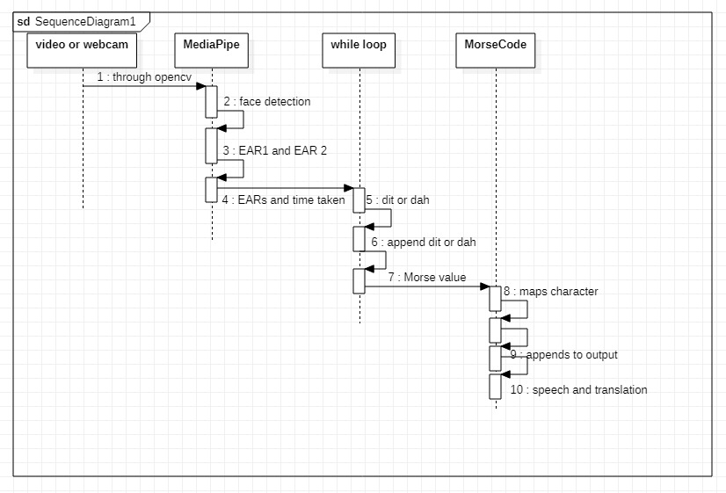

Figure 3.4: Sequence Diagram for MorseCode Translator

CMRTC 13

#### 3.7 ACTIVITY DIAGRAM

It describes about flow of activity states.

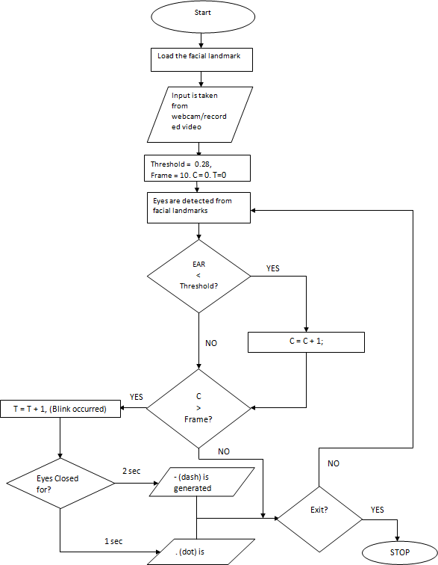

Figure 3.5: Activity Diagram for MorseCode Translator

# 4. IMPLEMENTATION

MORSECODE TRANSLATOR USING EYEBLINKS

#### 4.1 Code:

#### import cv2

#### import mediapipe as mp

#### import time

#### import utils

#### import math

#### def rescaleFrame( frame, percent=75):

#### width = int(frame.shape [1]* percent/ 100)

#### height = int(frame.shape [0] * percent/ 100)

#### dim = (width, height)

#### return cv2. resize(frame, dim)

#### def ld(img,results,draw=False):

#### img_h,img_w=img.shape[:2]

#### mesh_coord=[(int(point.x *img_w),int(point.y *img_h)) for point in results.multi_face_landmarks[0].landmark]

#### if draw :

#### [cv2.circle(img,p,2,(0,255,0),-1) for p in mesh_coord]

#### return mesh_coord

#### cap = cv2.VideoCapture(0)

#### pTime=0

#### mp_draw = mp.solutions.drawing_utils

#### mp_facemesh = mp.solutions.face_mesh

#### facemesh=mp_facemesh.FaceMesh(max_num_faces=1)

#### draw_spec=mp_draw.DrawingSpec(thickness=1, circle_radius=2)

#### ear1prev=[]

#### ear2prev=[]

CMRTC 15

MORSECODE TRANSLATOR USING EYEBLINKS

#### wordArray = []

#### isLong = False

#### blinkedFor = 0

#### notBlinkedFor = 0

#### wasBlinked = False

#### letterArray =""

#### letterIs=""

#### MorseCode = {

#### "SL": "A" ,

#### "LSSS":"B",

#### "LSLS": "C",

#### "LSS": "D",

#### "S": "E",

#### "SSLS": "F",

#### "LLS": "G",

#### "SSSS":"H",

CMRTC 16

MORSECODE TRANSLATOR USING EYEBLINKS

#### "SS": "I",

#### "SLLL": "J",

#### "LSL": "K",

#### "SLSS": "L",

#### "LL": "M",

#### "LS": "N",

#### "LLL": "O",

#### "SLLS": "P",

#### "LLSL": "Q",

#### "SLS": "R",

#### "SSS": "S",

#### "L": "T",

#### "SSL": "U",

#### "SSSL": "V",

#### "SLL": "W",

CMRTC 17

MORSECODE TRANSLATOR USING EYEBLINKS

#### "LSSL": "X",

#### "LSLL": "Y",

#### "LLSS": "Z"}

#### while True:

#### success, img = cap.read()

#### try:

#### scaled=rescaleFrame (img, 150)

#### imgRGB=cv2.cvtColor(scaled, cv2.COLOR_BGR2RGB)

#### results = facemesh.process (imgRGB)

#### except:

#### break

#### cTime = time.time()

#### while cTime==0 or pTime==cTime:

#### cTime=time.time()

#### fps = 1/(cTime-pTime)

#### pTime = cTime

#### count = 0

#### if results.multi_face_landmarks:

#### m_c=ld(img,results,True)

#### cv2.imshow("image",img)

#### if cv2.waitKey(1) & 0xFF == ord('q'):

#### break

#### if results.multi_face_landmarks:

#### for faceLm in results.multi_face_landmarks:

#### mp_draw.draw_landmarks(scaled, faceLm, mp_facemesh.FACEMESH_CONTOURS, draw_spec, draw_spec)

CMRTC 18

MORSECODE TRANSLATOR USING EYEBLINKS

#### ear1=abs((faceLm.landmark [160].x-faceLm.landmark[144].x)**2-(faceLm.landmark[160].y-faceLm.landmark [144].y)**2)+abs((faceLm.landmark[158].x-faceLm.landmark[153].x)**2-(faceLm.landmark[158].y-faceLm.landmark[153].y)**2 )/abs(((faceLm.landmark[33].x-faceLm.landmark[133].x)**2)-((faceLm.landmark[33].y-faceLm.landmark[133].y)**2))

#### ear2= abs((faceLm.landmark [385].x-faceLm.landmark[380].x)**2-(faceLm.landmark[385].y-faceLm.landmark [380].y)**2)+abs ((faceLm.landmark[387].x-faceLm.landmark[373].x)**2-(faceLm.landmark[387].y-faceLm.landmark[373].y)**2 )/abs(((faceLm.landmark[362].x-faceLm.landmark[263].x)**2)-((faceLm.landmark[362].y-faceLm.landmark[263].y)**2))

#### #print("ears")

#### #print(ear1,ear2)

#### if count>10:

#### count=0

#### else:

#### count=count +1

#### if len(ear1prev) >10:

#### ear1prev[count] = ear1

#### isLong = True

#### else:

#### ear1prev.append(ear1)

#### if len(ear2prev) >10:

#### ear2prev[count] = ear2

#### isLong=True

#### else:

#### ear2prev.append(ear2)

#### if isLong:

#### if((ear1prev[abs(count-9)]*0.68>ear1) and (ear2prev[abs(count-9)]*0.68>ear2)):

#### wasBlinked = True

#### #print("blink")

CMRTC 19

MORSECODE TRANSLATOR USING EYEBLINKS

#### blinkedFor=blinkedFor+1

#### else:

#### #print("bf",blinkedFor,fps,(fps*.7),int(fps/6.8))

#### if (blinkedFor>(fps*.7)):

#### print("LONG blink")

#### letterArray = letterArray+ "L"

#### blinkedFor=0

#### elif(blinkedFor>int(fps/6.8)):

#### print("SHORT blink")

#### letterArray=letterArray + "S"

#### blinkedFor=0

#### else:

#### notBlinkedFor=notBlinkedFor+1

#### #print("no blink")

#### if (notBlinkedFor>fps*2):

#### print(letterArray)

#### if letterArray in MorseCode:

#### letterIs=MorseCode[letterArray]

#### wordArray.append(letterIs)

#### print(wordArray)

#### letterArray=""

#### letterArray=""

#### notBlinkedFor=0

#### cap.release()

#### cv2.destroyAllWindows()

CMRTC 20

MORSECODE TRANSLATOR USING EYEBLINKS

#### out=""

#### for i in wordArray:

#### out+=i

#### print(out)

#### from googletrans import Translator

#### from gtts import gTTS

#### from playsound import playsound

#### translator = Translator()

#### t=translator.translate(text=out,src="en",dest="hi")

#### print(t)

#### speak = gTTS(text=t.text, lang="hi", slow=False)

#### print(speak)

#### speak.save("D:\\captured_voice1.mp3")

#### playsound("D:\\captured_voice1.mp3")

CMRTC 21

# 5. SCREENSHOTS

MORSECODE TRANSLATOR USING EYEBLINKS

#### Face Tracking With JavaScript on the Browser (Mobile or Desktop) | by Andy Kong | Better Programming

#### 5.1 Face mesh landmarks

#### 

#### 5.2 Left eye landmarks

#### 

#### 5.3 Right eye landmarks

CMRTC 22

#### 

MORSECODE TRANSLATOR USING EYEBLINKS

#### Morse code chart – MODERN OUT

#### 5.4 General morsecode

#### 

#### C:\Users\Srikar.G\Desktop\Major\img-1.jpeg

#### 5.5 morsecode for hello, hello converted to hindi

CMRTC 23

#### 

MORSECODE TRANSLATOR USING EYEBLINKS

#### 

#### C:\Users\Srikar.G\Desktop\Major\img-2.jpeg

#### 5.6 morsecode for egg, egg converted to telugu

#### C:\Users\Srikar.G\Desktop\Major\img-3.jpeg

#### 5.7 morsecode for welcome, welcome converted to japanese

CMRTC 24

# 6. TESTING

MORSECODE TRANSLATOR USING EYEBLINKS

## 6. TESTING

### 6.1 INTRODUCTION TO TESTING

The purpose of testing is to discover errors. Testing is the process of trying to discover every conceivable fault or weakness in a work product. It provides a way to check the functionality of components, subassemblies, assemblies and/or a finished product. It is the process of exercising software with the intent of ensuring that the Software system meets its requirements and user expectations and does not fail in an unacceptable manner. There are various types of test. Each test type addresses a specific testing requirement.

### TYPES OF TESTING

**6.2.1 UNIT TESTING**

Unit testing involves the design of test cases that validate that the internal program logic is functioning properly, and that program inputs produce valid outputs. All decision branches andinternalcodeflowshouldbevalidated.Itisthetestingofindividualsoftwareunitsoftheapplication

.it is done after the completion of an individual unit before integration. This is structural testing, that relies on knowledge of its construction and is invasive. Unit tests perform basic tests at the component level and test a specific business process, application, and/or system configuration. Unit tests ensure that each unique path of a business process performs accurately to the documented specifications and contains clearly defined inputs and expected results.

### 6.2.2 INTEGRATION TESTING

Integration tests are designed to test integrated software components to determine if they actually run as one program. Testing is event-driven and is more concerned with the basic outcome of screens or fields. Integration tests demonstrate that although the components were individually satisfied, as shown by successful unit testing, the combination of components is correct and consistent. Integration testing is specifically aimed at exposing the problems that arise from the combination of components.

CMRTC 25

MORSECODE TRANSLATOR USING EYEBLINKS

### 6.2.3. FUNCTIONAL TESTING

Functional tests provide systematic demonstrations that functions tested are available as specified by the business and technical requirements, system documentation, and user manuals.

Functional testing is centered on the following items:

Valid Input : Identified classes of valid input must be accepted.

Invalid Input : Identified classes of invalid input must be rejected.

Functions : Identified functions must be exercised.

Output : identified classes of application outputs must be exercised.

Systems/Procedures : interfacing systems or procedures must be invoked.

The organization and preparation of functional teats are focused on requirements, key functions, or special test cases. In addition, systematic coverage pertaining identifying Business process flows; data fields, predefined processes.

### 6.3. TEST CASE

|  |  |  |  |  |
| --- | --- | --- | --- | --- |
| Test case ID | Test case name | Purpose | Input | Output |
| 1 | Test Case 1 | To translate Morse code into  Speak able language | **.**  **_ _ .**  **_ _ .** | EGG  In Telugu  (text=గుడ్డు, pronunciation=Guḍḍu),  MP3 FILE |
| 2 | Test Case 2 | To translate Morse code into  Speak able language | **. _ _**  **.**  **. _ . .**  **_ . _ .**  **_ _ _**  **_ _**  **.** | WELCOME,  In Japanese  (text=ようこそ, pronunciation=Yōkoso,  MP3 FILE |
| 3 | Test Case 3 | To translate Morse code into  Speak able language | **. . . .**  **.**  **. _ . .**  **. _ . .**  **_ _ _** | HELLO,  In Hindi  (text=नमस्ते, pronunciation=namaste),  MP3 FILE |

CMRTC 26

MORSECODE TRANSLATOR USING EYEBLINKS

* + 1. **TEST CASE DESCRIPTION**

**TEST CASE 1 :** When we give input the code try’s to translate it into ENGLISH and then to other specified Language along with speech i.e to EGG and గుడ్డు .

**TEST CASE 2 :** When we give input the code try’s to translate it into ENGLISH and then to other specified Language along with speech i.e to WELCOME and ようこそ.

**TEST CASE 3 :** When we give input the code try’s to translate it into ENGLISH and then to other specified Language along with speech i.e to HELLO and नमस्ते.

CMRTC 27

# 7. CONCLUSION

MORSECODE TRANSLATOR USING EYEBLINKS

## 7. CONCLUSION & FUTURE SCOPE

### 7.1. PROJECT CONCLUSION

* The existing system was quite complicated and people working on this system must have to remember a lot.
* Whereas our system has resolved the complicated issues and added predictive power to it.
* Here we translate not only with one language; we can translate to more regional languages and converting the generated text into the speech.

### 7.2. FUTURE SCOPE

* Can improve accuracy by improving the model.
* Can make it more dynamic by using any angle of face to the camera.
* Can be used to implement a GUI application.

CMRTC 28

# 8. BIBLIOGRAPHY

MORSECODE TRANSLATOR USING EYEBLINKS

## 8. BIBLIOGRAPHY

### 8.1 REFERENCES

* + 1. <https://www.jetir.org/papers/JETIR2105194.pdf>
    2. <https://google.github.io/mediapipe/solutions/face_mesh#python-solution-api>
    3. <https://www.kaggle.com/>
    4. [www.wikipedia.com/](http://www.wikipedia.com/)

### 8.2 GITHUB LINK

https://github.com/sainathchp/major-project

CMRTC 29